This post was published to Code Blog at 12:17:00 PM 10/10/2016

Training Material - Nick M Technical Training

Category .NET ; Angular ; Azure ; C# ; Cloud

​All,

Here is a link to the training powerpoints and sample code from the technical training.

[https://dow-vsts.visualstudio.com/Market%20Sell/CDMC%20-%20Enterprise%20Mobility%20Team/_versionControl?path=%24%2FMarket%20Sell%2FTraining%2FNickMTechnicalTraining&version=T&_a=contents](https://dow-vsts.visualstudio.com/Market%20Sell/CDMC%20-%20Enterprise%20Mobility%20Team/_versionControl?path=$/Market%20Sell/Training/NickMTechnicalTraining&version=T&_a=contents)

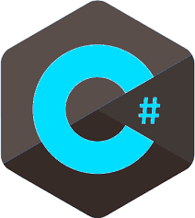

Thanks,

Nick Theile